**Exercise 6: Configuring Beans with Annotations**

**Scenario:**

You need to simplify the configuration of beans in the library management application using annotations.

**Steps:**

1. **Enable Component Scanning:**
   * Update **applicationContext.xml** to include component scanning for the **com.library** package.
2. **Annotate Classes:**
   * Use **@Service** annotation for the **BookService** class.
   * Use **@Repository** annotation for the **BookRepository** class.
3. **Test the Configuration:**
   * Run the **LibraryManagementApplication** main class to verify the annotation-based configuration.

<?xml version="1.0" encoding="UTF-8"?>

<beans xmlns="http://www.springframework.org/schema/beans"

xmlns:context="http://www.springframework.org/schema/context"

xmlns:aop="http://www.springframework.org/schema/aop"

xmlns:xsi="http://www.w3.org/2001/XMLSchema-instance"

xsi:schemaLocation="

http://www.springframework.org/schema/beans

https://www.springframework.org/schema/beans/spring-beans.xsd

http://www.springframework.org/schema/context

https://www.springframework.org/schema/context/spring-context.xsd

http://www.springframework.org/schema/aop

https://www.springframework.org/schema/aop/spring-aop.xsd">

<context:component-scan base-package="com.library"/>

<aop:aspectj-autoproxy/>

<bean id="bookRepository" class="com.library.repository.BookRepository" />

<bean id="bookService" class="com.library.service.BookService">

<property name="bookRepository" ref="bookRepository" />

</bean>

</beans>

**import** org.springframework.stereotype.Service;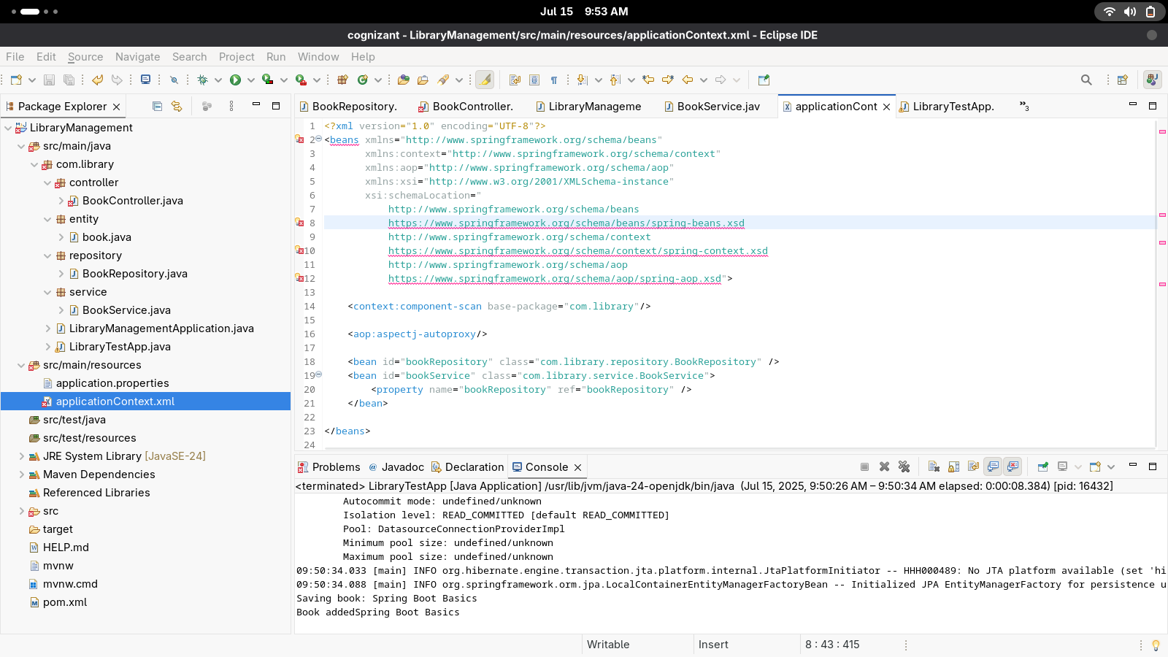

**import** org.springframework.beans.factory.annotation.Autowired;

@Service

**public** **class** BookService {

@Autowired

**private** BookRepository bookRepository;

**public** BookService(BookRepository bookRepository) {

**this**.bookRepository = bookRepository;

}

**public** **void** setBookRepository(BookRepository bookRepository) {

**this**.bookRepository = bookRepository;

}

**public** **void** addbook(String name) {

bookRepository.book(name);

System.***out***.println("Book added" + name);

}

**}**

**package** com.library.repository;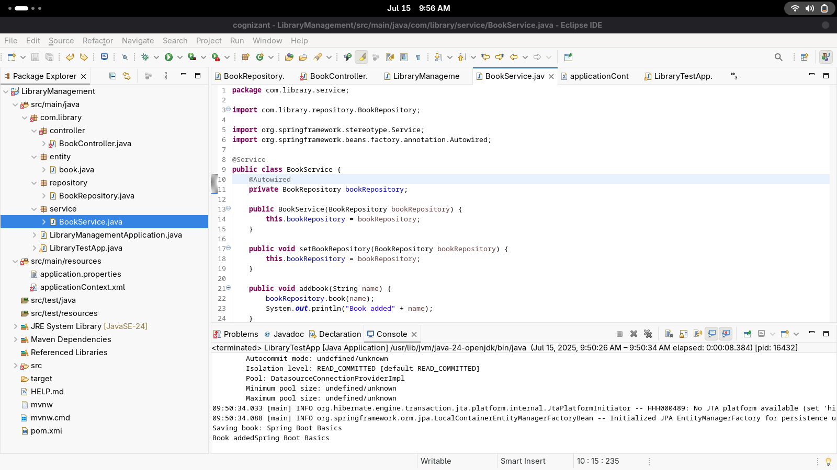

**import** org.springframework.stereotype.Repository;

@Repository

**public** **class** BookRepository {

**public** **void** book(String name) {

System.***out***.println("Saving book: " + name);

}

}

